Управление образования Мангистауской области Учебно-методический кабинет технического и профессионального образования Мангистауской области

МЕТОДИЧЕСКОЕ ПОСОБИЕ
Английский язык в сфере туризма для специальностей «Организация обслуживания гостиничных хозяйств», «Организация питания» и «Гид-переводчик».

Актау 2015
Утверждено:
Советом МО УМК ТиПО
Протокол № __________
«___» _________2015 г.

Составила: Аубекерова Л.Е – преподаватель английского языка, ГККП «Мангистауский колледж туризма»

В методическом пособии приведены теоретические и практические материалы для изучения английского языка. Пособие рекомендовано для преподавателей колледжей.

Рекомендовано:
Экспертной комиссией по
специальностям педагогики
и общеобразовательных дисциплин
Протокол №__________
«__»_____2015г.

Пояснительная записка
Туризм сегодня является одной из наиболее высокодоходных и динамично развивающихся отраслей экономики, оказывающих сильное мультипликативное влияние на совокупную деятельность различных секторов экономики. Индустрию туризма и гостеприимства следует считать комплексообразующей отраслью, основанной на интегрированном использовании всего экономического, культурного и природного потенциала территории.
По оценке ведущих экспертов, индустрия туризма в XXI веке является одной из трех важнейших движущих сил в обслуживающем секторе мировой экономики наряду с телекоммуникациями и информационными технологиями. В туристской отрасли в настоящее время занято около 220 млн. человек, или более 10% трудоспособного населения мира.
XXI век объявлен веком туризма. За последние несколько десятилетий туризм стал доступен широким слоям населения, в том числе и в нашей стране. Одновременно с ростом общего числа туристов заметное развитие получили инфраструктура туризма и ее основной компонент – гостиничный сектор. Отели стремятся получить свою долю бизнеса и всячески пытаются убедить туристов истратить деньги на приобретение предоставляемых ими гостиничных услуг.
С возникновением туристического рынка в Казахстане появились потребность в подготовке специалистов для сферы туризма и гостиничного бизнеса. Образовательные учреждения приступили к подготовке профессиональных кадров.
Для индустрии туризма и гостиничного бизнеса знание английского языка является как ежедневной необходимостью, так и важным условием для успешной карьеры.
Для успешной работы, необходимо не только понимать систему языка, но и уметь эффективно и уместно применять различные языковые структуры.
Данное методическое пособие предназначено для студентов колледжей, обучающихся по специальностям туристического профиля («Организация питания», «Гостиничный бизнес», «Гид-переводчик в сфере туризма»).
Туристический и гостиничный бизнес в первую очередь клиента - ориентирован, поэтому при обучении английскому так важно развивать навыки говорения. В связи с этой необходимостью в методическом пособии учтены коммуникативные упражнения.
В пособии содержатся приближенные к реальности задания, основанные на аутентичных (подлинных) документах и текстах, что позволяет студентам и учащимся получить представление о реальной работе гостиниц, ресторанов, туристических компаний и отрасли в целом.

Tourism industry
Tourism is becoming more and more popular. It’s one of the best ways to spend a holiday. It’s also a well-developed business nowadays. There are so many means of travelling around the world, such as jet-planes, express trains, cruise liners, comfortable buses, personal cars and else. We can choose what’s best for us. I’m glad that tourism has become more available.
Twenty years ago not many people travelled overseas for their holidays. The majority of people stayed to have holidays in their country. Today the situation is different and the world seems much smaller.
It is possible to book a holiday to a seaside resort on the other side of the world. Staying at home, you can book it through the Internet or by phone. The plane takes you straight there and within some hours of leaving your country, you can be on a tropical beach, breathing a super clean air and swimming in crystal warm water of tropical sea.
People travel from the very beginning of their civilization. Thousands years ago all people were nomads and collectors. They roamed all their lives looking for food and better life. These way human beings populated the whole planet Earth. So, travelling and visiting other places are the part of our consciousness. That is why tourism and travelling are so popular.
Nowadays people travel not only for pleasure but also on business. People have to go to other countries for taking part in different negotiations, for signing some very important documents, for participating in different exhibitions, in order to exhibit the goods of own firm or company. Travelling on business helps people to get more information about achievements of other companies, which will help making own business more successful.
There are a lot of means of travelling: travelling by ship, by plane, by car, walking. It depends on a person to decide which means of travelling one would prefer.

HOTEL SERVICE

Nowadays people travel on business and as tourists more than in the past. No businessman can avoid being a paying guest every now and then. In big cities there are a lot of good hotels. Accommodations as well as rates vary from hotel to hotel. There are deluxe hotels, the most luxurious and the most expensive, resort hotels used for entertainment or recreation. Still, if you do not want to get disappointed, it is advisable to book accommodation beforehand by fax or telephone, especially if you are visiting the town during the summer months. If you do not book accommodation beforehand, you may have to leave the hotel because it is fully booked up. That would be an unpleasant experience, especially if you arrived late at night.
Rooms in most hotels have all modern conveniences: central heating, air conditioning, bathroom, hairdryer, trouser press, telephone, satellite TV and others. Service is usually quite satisfactory. You can take a single room, a double room or a suite, charges varying accordingly. If you can't stand the noise of the street, do not take an outside room, ask for an inside one.
Service is supposed to begin at the door. When your taxi stops at the entrance to the hotel the doorman and the bellboy help you with the luggage. The doorman is very important during the reception procedure. He is stationed at the entrance to the hotel and assists the guests in and out of taxis and cars, calls for cabs. In the lobby of a hotel there is a registration or front desk where the guests check in and out, pick up and deposit keys and so on. The guest is given a registration card to fill out the name and permanent address. The desk clerk or receptionist enters the guest’s room number, the room rate, and the arrival and departure dates into the computer. Then he asks the guest to sign his or her name.
When the guests are through with the formalities, the bellboy takes them and their luggage up in the lift and shows them to their room. He shows them where the light switches are and explains the use of the room appliances, such as the television set, cooking facilities, if any, and the air conditioning. He can also run errands for you. Now that you have been settled in a hotel room and have been given the key of it, you become a regular hotel guest.
At the hotel you can get various services. If you want to have your suit pressed or dry cleaned, your shirt ironed, or your laundry done, you should ring for the maid and she will see to it that everything is done. You can also have your meals served in your room.
In the lobby of a hotel there are a lot of offices: a booking office, post and telegraph offices, an information desk supervised by the concierge. At the information desk you can enquire about the departures and arrivals of trains and flights, about telephone numbers and addresses of offices and private individuals and about a lot of other things. Concierges are always ready to help the guests and provide them with all kinds of useful information. Besides, there is a newsstand, a bookstall, a kiosk selling picture postcards and souvenirs. Cosmetics and liquor are sold too, but with a sales tax. At the airport you can buy them tax-free. At the booking office they can book for you seats at the theatre or on the plane, or hotel accommodation in another town. In the same building there are also restaurants, bars, cafeterias, beauty parlours, saunas, steam rooms and massage rooms, along with fully equipped supervised gyms and swimming pools.

HOTEL STAFF
Here are some more employees from different hotels around the world. What do you think they do? Match each photo with a job.
1 2 3
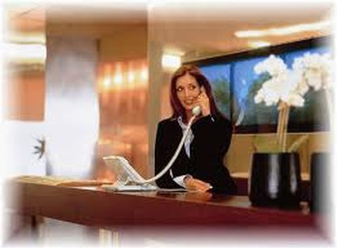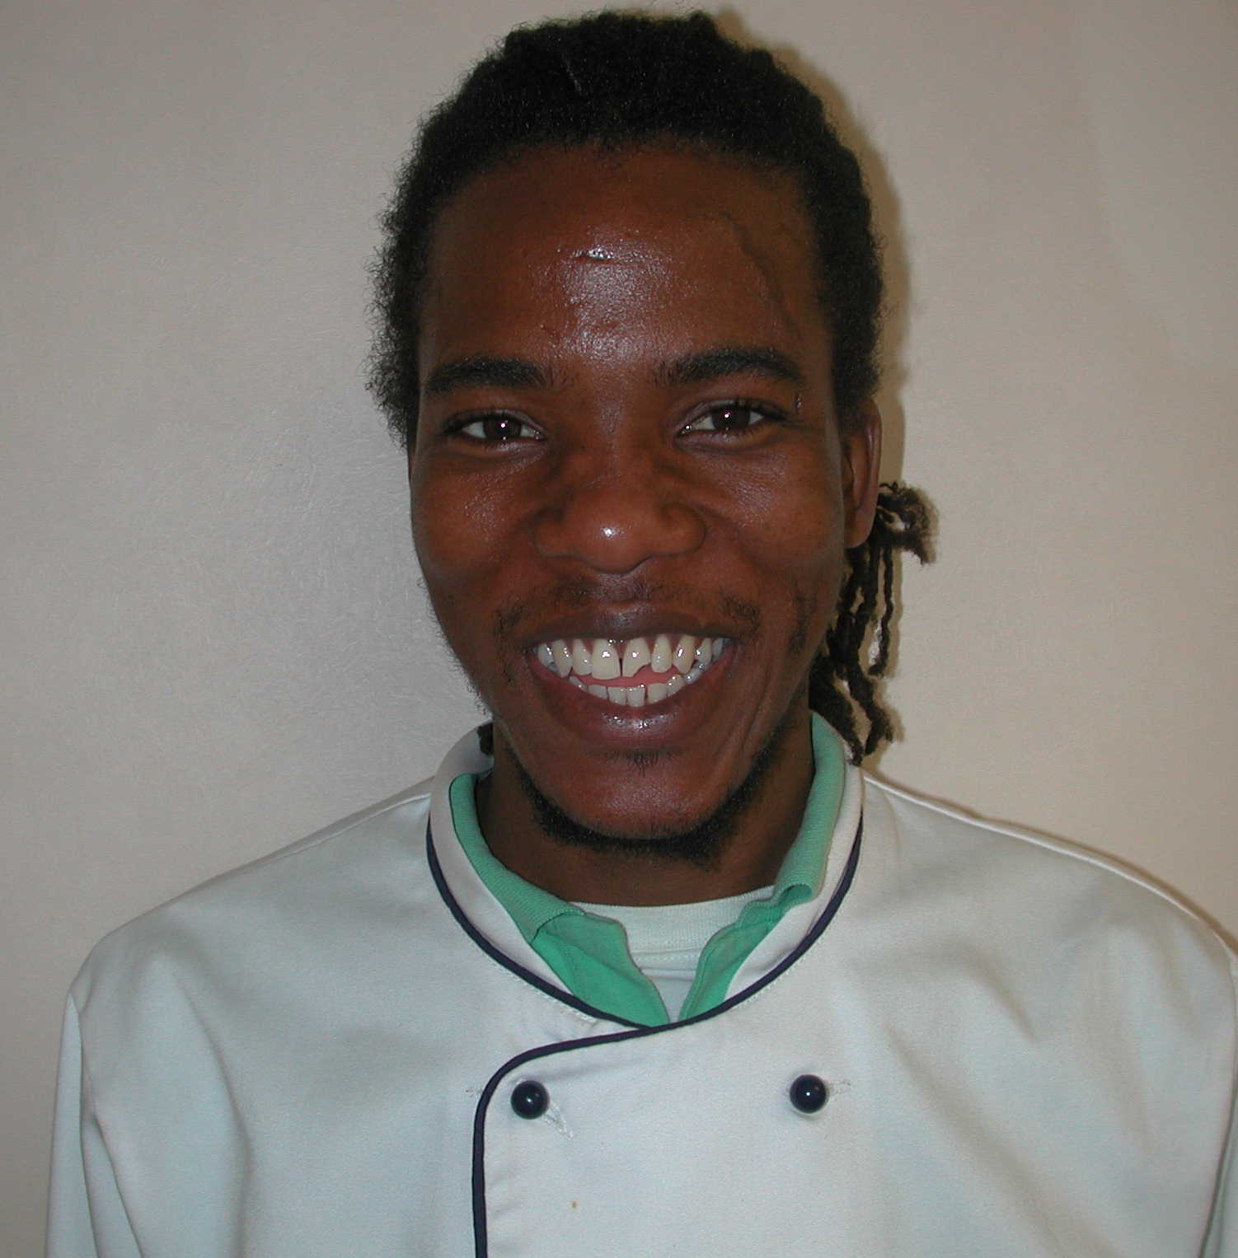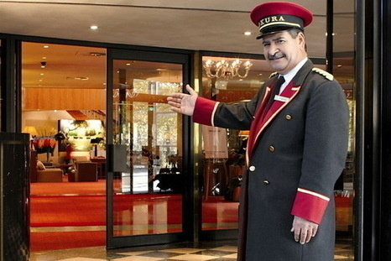
Zita Akoun Jimmy
4 5 6
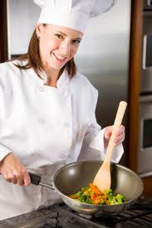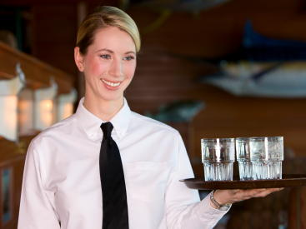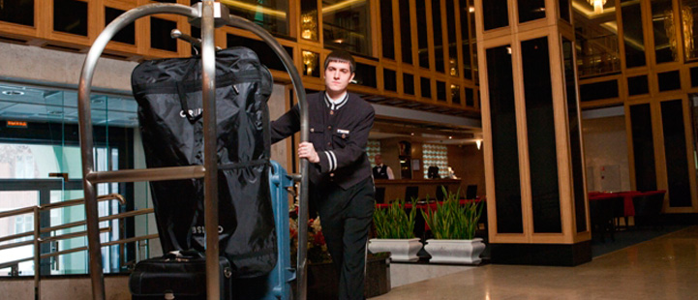
Kate Jane Kris
7 8 9 10
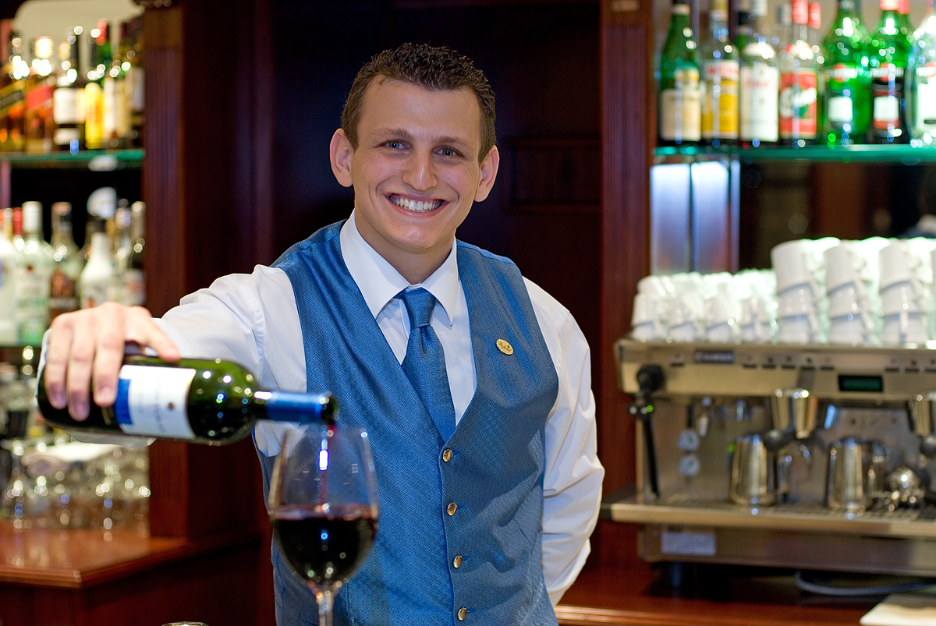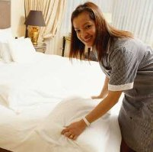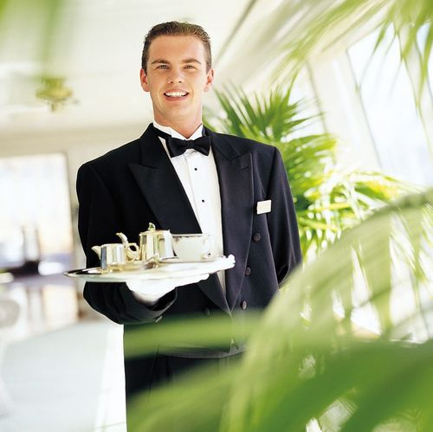
Mike Alice Justin Kelly
A I’m a commissionaire. B I’m receptionist. C I’m waiter.
D I’m a sous-chef. E I’m a kitchen assistant. F I’m porter.
G I’m a bar person. H I’m a chambermaid/ room attendant.
I I’m a management trainee. J I’m waitress.
Have Some Fun!
Use the words from the boxed list to complete the sentences below.
Then place the answers in the puzzle.
bellhop  concierge  direct  escort  first | fitness  floor  greeter  guest  left | nice  service  turn
 | 1 |  |  | 2
 | 3 |  |  |  |  | 4
 | 5
 |  |  |  | 6 |  |  |  |  |  | 7
8
 |  |  |  |  |  | 9 |  | 10
 | 11
 |  |  |  |  |  |  |  | 12
Across
1. The ________ helps. Guests find things to do in the city.
3. “You re our________.”
5. “If we have time or if a guest needs help, we_____ . The person where he or she wants to go.”
8. Lee is a______. That’s her job.
11. Hotel workers must give good_____to their guests.
12.The pool is next to the______center.

Down
2. “Be kind and____to the guests”
3. A_____is a worker who says hello to the guests and visitors at the entrance.
4. “First______right,then turn left”.
6. The lobby is on the first______.
7. “I can______you to the elevators.”
9. The ground floor is the______floor.
10. “Don’t turn right, turn______.”

Check Your Understanding
Step 1: Draw a line from what a guest at the City Garden Hotel says to what a worker replies.
Guest says: Worker replies:
1. Where are the restroom? a. It’s my pleasure.
b. In the back of the lobby, near
the reception desk.
2. Excuse me. Can you tell me a. Yes, it’s on the third floor.
where the conference room is? b. Certainly, I can.
3. Pardon me. Where can I find the a. See you later
Rent-an-Avto desk? b. Let me show you. Come
this way, please.
4. Can you please have someone a. Of, course. I can send
pick up my luggage in an hour? someone to pick it up.
What is your name and
room number, please?
b. Bring it to the front desk,
and we’ll take care of it
for you.
Step 2: Circle the words that a worker uses to help a guest find a specific place.

Come this way? Please.

See you later.
Excuse me.
It’s there. Do you see where I’m pointing?
It’s on the third floor.
It’s the last door at the end of the corridor.
Pardon me.
My pleasure.
Let me show you the way.

Practice
Step 1: Use the words or phrases in the box to fill in the spaces below.
- “ I’m the new ________ and ________ here”.
- “ Can I leave my _________ at the bell desk until tomorrow?
- “ I’m not sure? But I’ll _______________ for you.
- “ I’ll _______________ it.
- “ Just remember to smile and to be ________ and _________ .”
- “ Of course? You can count on your _____________ for help.”
- “ We’re a ___________ here”.
- “ It’s no ____________ at all.”
Step 2: You are a bell person. Circle the letter of the best answer.
1. A guest asks you a question, and you don’t know the answer. You say:
a. “I don’t know what to do. Ask somebody else.”
b. “I can take care of that for you.”
c. “I can’t help you.”
d. “I’m not sure, but I’ll find out for you. Just a moment, please.”
2. Your job is to:
a. sit at the bell desk
b. help the guests get what they need
c. talk on the phone
d. ask questions
3. If you help doing your job, you can:
a. try to do it by yourself
b. give up and go home
c. tell someone to do it for you
d. ask your co-workers for help
Draw a line from the question on the left to the correct answer on the right.
bellman  co-workers  courteous  find out  friendly | laptop computer  team  trouble  van driver  take care of

1. Where can I rent a car? a. It’s in the lobby next to the City
Bistro. Do you know where that is?
2. The security lock on the b. Our pool, sauna and spa are open
door to my room doesn’t from 8 a.m. to 11 p.m. daily.
lock. What can I do?
3. Where can I find the c. I’ll call the engineering coffee shop? department. Someone will fix it
for you.
4. What are the hours for d. There’s a car rental desk in the.
the pool? lobby next to the coffee shop.
5. Do you have any e. We have live music and dancing
entertainment in the from 9 p.m. to 1 a.m. on Friday
cocktail lounge? and Saturday in the City Bistro.
6. Where can we buy some f. Our coffee shop and room
souvenirs? service are available until
midnight. We also have vending
machines with drinks and snacks
on each floor.
- Where can I get a snack g. Yes, it is. We just this late at night? completed our room
renovations? And we are
ready to serve our
disabled guests.
- Could we please have some h. Certainly. I’ll call the more blankets in room 203? housekeeping department
for you. They’ll send some
right up.
- Do you have a dry cleaners i. We have a gift shop on the
in the hotel? first floor.
- How can I get a wake-up call j. Just dial the hotel operator for tomorrow? and say what time you
would like to get up.
11. When does Happy Hour start? k. Yes, we have one-day
service on dry cleaning.
Dial the bell desk at 333
for pickup.
- Is your hotel wheelchair l. It starts on weekdays at 4
accessible? p.m. It’s over at 6 p.m.

HOTEL BEDROOM
broom  cart  crib  facial tissue | iron and ironing board  pillowcase  sheets  toilet tissue | toothbrush  towels  vacuum cleaner
Write the correct word from the box beside each picture below.
- 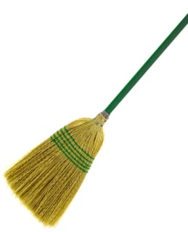_________ 7. ________
- 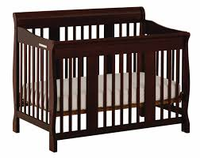 ________ 8. ________
- 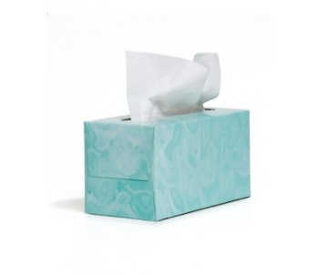_________ 9. 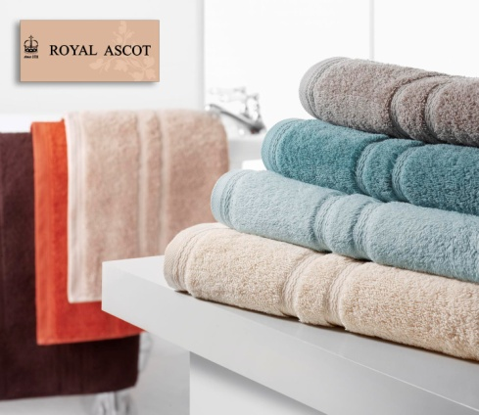 _______
- 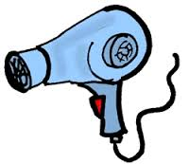________ 10. 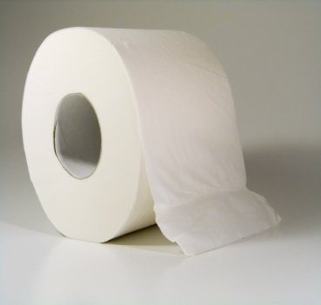 ________
- 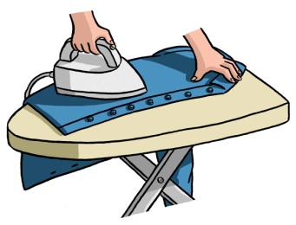_______ 11. 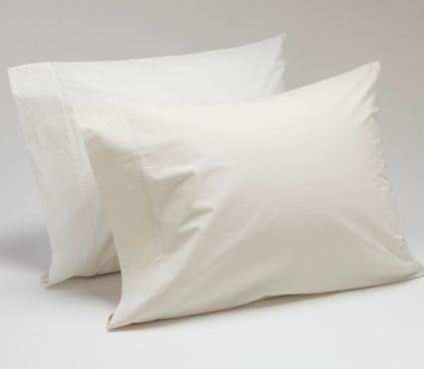 _________
- 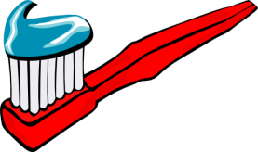 ________ 12. 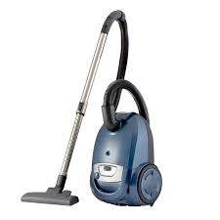_________

Words to Know
bathtub bedspread  carpet  fixtures  furniture  glass cleaner  Ice bucket  linen  laundry bag  liner | sink  stain  tear  toilet  towel rack  tray  wall  wastebasket | (to) deposit  (to) display  (to) dust  (to) empty  (to) hang  (to) make up a room  (to) remove | (to) replace  (to) sanitize  (to) scrub  (to) spray  (to) sweep  (to) wipe burned-out dirty

- ________________ the wastebaskets.
- ________________ the furniture and the TV.
- ________________ dirty towels in laundry bag.
- ________________ the carpet.
- ________________ the bathroom floor with a broom.
- ________________ the sink.
- ________________ the toilet.
- ________________ toiletries in the basket.
- ________________ used sheets from the bed.
- ________________ the bed with clean sheets.
- ________________ glass cleaner on the mirrors windows.
- ________________ clean towels on the towel racks.

The words below name things in the pictures. The pictures have empty circles. Fill in the empty circles on each picture with the letters of the correct names on the right. The first one is done for you.
- 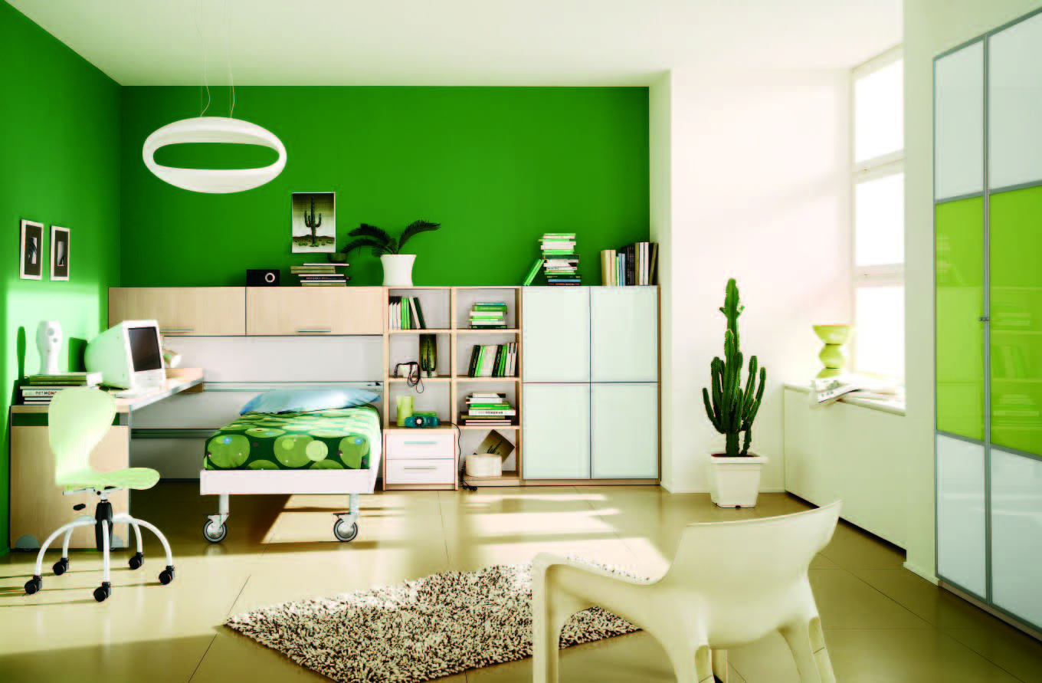bed f. sheet
- bedspread g. TV
- carpet h. table
- window
- pillow

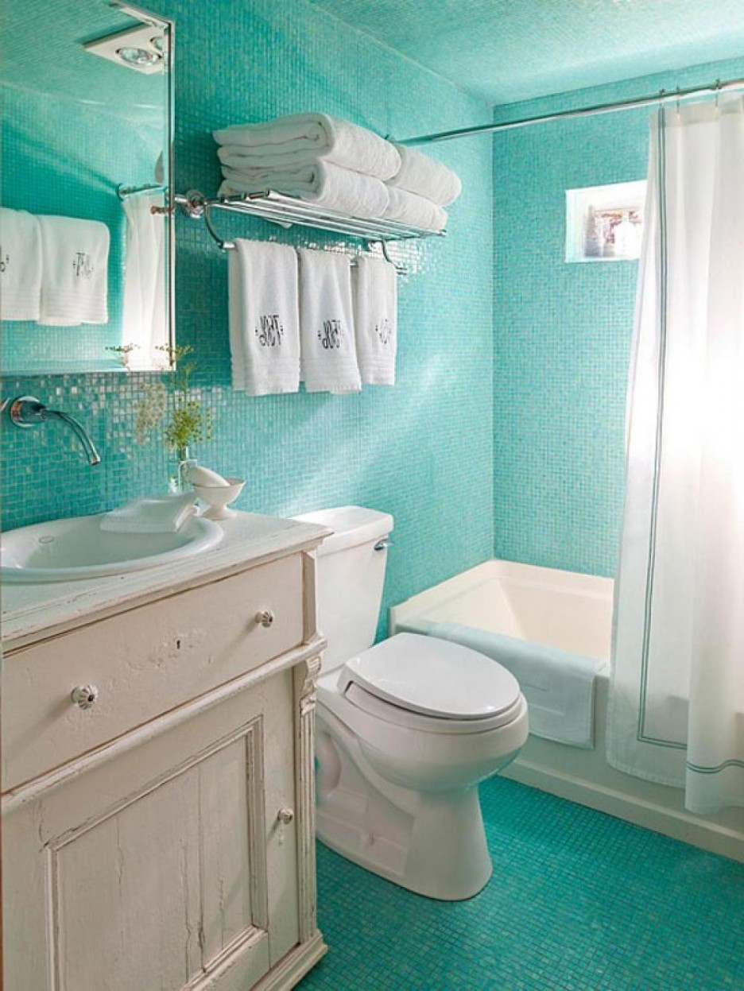 a. bathtub d. toilet
b. floor e. towels
c. sink f. mirror

Use the words in the box to complete the sentences below.
Then place the answers in puzzle.
attendant  cart  crib  disturb  housekeeping  key | knocks  lines  sheets  shine  sweep  trainee

 |  |  |  |  |  | 1
 |  |  |  |  |  |  |  |  |  |  |  | 2
 |  |  |  | 3 |  |  |  |  |  | 4
 |  |  |  | 5
 | 6 |  |  |  |  |  |  |  |  | 7
 |  |  |  |  |  |  | 8 |  | 9
10
 | 11

Across Down.
1."Use a broom to ______the floor." 1."Put clean _____on the bed. "
4. A baby sleeps in a ________. 2. The sign on the doorknob says
"Do Not______.
5. Another name for a
housekeeper is room ______. 3. A new employee is a ______.
7. A housekeeper keeps supplies 6. A housekeeper ___________
on a _______. on the door before opening it.
10. Workers in the ______ 8. "Use a _____ to open the door.
department clean the hotel rooms.
11. Can you "Make it ______ "? 9. Sheets, pillowcases, and towels are all _________.

Step 1: There are many things to do clean a guest room. Imagine you are a housekeeper. Read each numbered item below. Then draw a line from each numbered item to what you must do to correct the problem. The first one is done for you.
1. The carpet is not clean. a. I sweep it with a broom.
2. The floor is dirty. b. I empty it.
3 The wastebasket is full. c. I dust them.
4. There is no hotel directory in the room. d. I vacuum it.
5. The air conditioner is no high in a vacant e. I put one on the table.
room. f. I hang some up.
6. The furniture and TV set are dusty. g. I scrub it.
7. The coffeemaker is missing from h. I report the loss to the he room. floor supervisor. 7.The coffeemaker is missing from the room. h. I report the loss to the floor supervisor.
8. The sink is dirty. i. I turn it down. i. I turn it down.
9. There are no towels in the bathroom. j. I pick them up and
deposit them in the
laundry bag. j. I pick them up and deposit them in the laundry bag.
10. The sheets on the bed need changing. k. I remove them and put
clean ones on. k. I remove them and put clean ones on.
11. A guest left a bathing suit in the room. l. I call for someone to
take it to lost and found. l. I call for someone to take it to lost and found.
12. Dirty towels are on the floor.

Step 2: Put an X in front of anything a housekeeper does.
_____1.Takes luggage to guests' ______7. Checks rooms for items
guest’s might have left. rooms.
_____2. Gives supplies to guests ______8. Opens hotel doors
for guests who forget their
keys.
_____3. Answers the phones ______9. Says "hello» and
"good morning" to guests in
the hall.
______4. Smiles t guests ______10. Opens a door when
there is a «Do Not Disturb"
sign on it.
______5. Makes up guests rooms ______11. Uses towels to clean
rooms.
______6. Knocks before opening them.
RESERVATION DESK
Step 1: You are not front desk clerk at the City Garden Hotel.
Complete the conversation. Then practice it with a partner.
You: Welcome to the _________________________________.
How__________________________________________?
Guest: I'd like to check in.
You: Do you_________________________________________?
Guest: Yes, I do. My name is Henry Puccini.
You: Could you_______________________________________?
Guest: Pas in Peter, u , double c, i-n-i. I'd like a nonsmoking room.
You: Thank you. May I have your_________________________?
Guest: Here you are. Are there any good restaurants within walking distance?
You: The concierge_____________________________________.
Guest: Thank you.
You: How many card keys_______________________________?
Guest: ________________________________________________.
You: Here is your_________and here are your _______________.
Guest: Thank you very much.
You: ________________________________________________.

Step 2: Number the parts of the conversation below in order from 1 to 8.
____1. " I'd like to check in."
____2. " Do you have a reservation?"
____3. " Welcome to the City Garden Hotel.
How may I help you?"
____4. "Yes, I do. The name is Presley".
____5. "You're all set, Mr. Presley. Here is your card key. Enjoy your stay!"
____6. "P-r-e-s-l-e-y".
____7. " How do you spell that?"
____8. "Thank you. I will."

Read what twelve guests say below. Then circle the letter next
to the front desk clerk’s correct response.

- I’d like to check out.
- I’m sorry. I’m busy.
- Was everything satisfactory?
- Please talk to the bellman.
- I’d like to check in.
- What’s your room number?
- Do you have a card key?
- Do you have a reservation?
- Do you know any good restaurants within walking distance?
- No, I don’t.
- We never recommend restaurants.
- The concierge can recommend some local restaurants.
- I misplaced the card key to room 304.
- May I see your identification, please?
- How many keys do you need?
- Here’s my driver’s license.
- Where do I register?
- You can register here at the front desk.
- You can register at the bell desk.
- You can register by phone.
- Do you have any rooms with queen-sized beds?
- How many I help you?
- Our rooms have either king-sized beds or double beds.
- Enjoy your stay!
- Can I send a fax from here?
- Yes, ma’am. Just a moment. Please. I’ll help you.
- The housekeeper can help you.
- What’s a fax?
- I’d like to put some things in the safe.
- Welcome to the City Garden Hotel.
- Yes, please.
- Certainly. I can help you with that.
- What’s your cancellation policy?
- I don’t want to talk about it.
- Notify us at least two days in advance to avoid any charges.
- Our check out time is 11:30 A.M
- Do you have any nonsmoking rooms for tonight?
- What’s your name, please?
- Anything else I can help you with?
- Yes, we do. Are you interested in a single or a double?
- How can I guarantee my reservation for late arrival?
- You can reserve a room for a convention.
- You can use your credit card.
- You can check out later.
- Do you have group rates for the convention?
- I’ll check on that for you.
- What’s your credit card number?
- Hospitality is our business.
HOW TO DEAL WITH COMPLANTS
Step 1: Read what the guest service manager tells her employees to do when quests complain.
“Today I’m going to talk about handling quest complaints. Remember, if a quest comes to you with a problem, it’s your problem. You must help resolve the problem. Sometimes quests are right when they complain, and sometimes they’re wrong. That’s not important. How we treat our quests is important. The information on this sign tells you what to do when a quest complains.”
- Listen carefully. Give the guest your total attention.
- Make eye contact and be sympathetic.
- Don’t interrupt. Let the guest finish talking.
- Apologize and acknowledge the guest’s situation.
- Repeat what the quest says to be sure you understand his or her feeling.
- Speak calmly and use a pleasant tone of voice.
- Say what you’ll do to resolve the situation.
- Follow up on what you told the quest you would do.
- If you promised to do something, do it!

“If a quest is irate and making a scene, you must invite him or her to a private location to avoid disturbing the other quests. Remember, the quest isn’t upset with you as a person. The quest just wants someone to listen to his or her problem.”
Put a check mark next to each statement that tells hotel employees how to handle guests’ complaints.
______ 1. Listen carefully to what the guest says.
_______ 2. Say, “Can you speak louder, please?
_______ 3. Speak calmly.
_______ 4. Interrupt the quest many times.
_______ 5. Say, “I’m sorry, it’s not my Problem.”
_______ 6. Say what you’ll do to resolve the situation.
_______ 7. After the quest leaves say, “Thank goodness he’s gone.”

________ 8. Follow up on what you told the quest you would do.

________ 9.Look at the floor and ceiling at all times.
_______ 10. If you promised to do something, do it.

Who Says What?
Step 1: Draw a line to match what the employee says with the guideline for handing a guest complaint.
- I’m very sorry you had to wait, a. Listen carefully
Mr. Johnson
- “Let me finish talking!” b. Follow up.

- “I’ll call the housekeeping c. Repeat what the quest said.
department right away.”

- “Did you get your suitcase, d. Apologize.
Mrs. Green?”
5. “You say no one has delivered e. situation.
your dry cleaning?”

6. “Please tell me what happened. f. Do not interrupt.
I’m a good listener, and I want
to help you solve this problem.”

REPLIES OF THE GOOD WORKERS
Imagine you are a hospitality worker. Circle the letter that shows the best way to finish each sentence.
- If a guest is angry, you should
- give the guest your full attention and listen until he or she finishes talking.
- tell the guest what you think before he or she finishes talking.
- call the manager right away.
- If a guest tells you a problem, you should
- ask a co-worker to help the quest.
- call the manager right away.
- help to resolve the problem.
- If a guest demands to see the manager, you should tell the guest
- that it is not possible.
- that you will check to see if the manager is in.
- that the manager is on vacation
- If you have to inform a guest about house policy. You should
- be very careful with your choice of words.
- Never ask the quest to cooperate.
- Try not to be polite

Draw a line from what a quest says to what a worker replies.
Guest says:
appreciate | step into | sorry | immediately
check | apologize | resolve | understand

- I’m very upset. I called three times, and no one came to fix the air conditioner.
- Can you do something about the trays in the hall? No one has picked them up.
- I demand to speak to the manager immediately!
- My room is dirty! It wasn’t cleaned well enough after the last quest.
- There’s a mistake on my bill. I didn’t have room service.
Worker replies:
- Certainly. Thank you for bringing it to our attention. I’ll have them picked up.
- I do apologize. I can understand how upset you must be. I’ll call the engineering department right now. Someone should be there to fix it very soon.
- I’m terribly sorry for the inconvenience. I’ll call housekeeping. Would you like another room?
- I’ll check to see if she’s in. Would you like a complimentary drink while you wait?
- Let me check your account, sir, to see where the problem is.

Say it Right
Use a word from the box to complete each sentence

1. I’m terribly ________________.
2. I can ___________ how upset you must be.
3. I really must ______________.
4. I’ll have that taken care of _______.
5. Please ______________ my office.
6. I’m certain that we can ______ the problem to your satisfaction.
7. We ___________________ your cooperation.

Step 1: Read the following statements about the Outstanding Service Award winner.
An Outstanding Employee:
- has a “can do” attitude and “goes the extra mile” for guests
- is available and dependable, and performs job duties well without direct supervision
-is a good team member and is cooperative and easy to work with
-can be depended upon to arrive at work on time, have a good attendance record, and take breaks as scheduled
- is polite, courteous, and helpful, and gets along well with guests, co-workers, and supervisors
-leaves personal issues at home and doesn’t spend working time on nonbusiness matters

Step 2: Put a check mark next to the statements that tell what a good hospitality worker does.

- _________ has a good attitude
- _________ smiles at guests
- _________ works as part of a team
- _________ never does his or her best
- _________ is prompt
- _________ makes eye contact with others
- _________ cannot work scheduled hours
- _________ knows safety and security procedures
- _________ breaks the rules
- _________ is dependable and hardworking
- _________ is available to work whenever asked
- _________ leaves personal business at home
- _________ has a good attendance record
- _________ is not flexible
- _________ apologizes to guests if necessary
- _________ does not spend work time on no work matters
- _________ is polite to guests and associates
- _________ takes lots of breaks
- _________ performs job duties well
- _________ produces good-quality work

RESTAURANT SERVICE
Restaurants
A restaurant is an establishment that serves prepared food and beverages to be consumed on the premises. The term covers a multiplicity of venues and a diversity of styles of cuisine. Restaurants are sometimes a feature of a larger complex, typically a hotel, where the dining amenities are provided for the convenience of the residents and, of course, for the hotel to maximise their potential revenue. Such restaurants are often also open to non-residents.
History
The term “restaurant” (from the French “restaurer”, to restore) first appeared in the 16th century, meaning “a food which restores”, and referred specifically to a rich, highly flavoured soup. The modern sense of the word was born in around 1765 when a Parisian soup-seller named Boulanger opened his establishment. The first restaurant in the form that became standard (customers sitting down with individual portions at individual tables, selecting food from menus, during fixed opening hours) was the Grand Taverne de Londres, founded in 1782 by a man named Beauvilliers.
Whilst inns and taverns were known from antiquity, these were establishments aimed at travellers, and in general locals would rarely eat there. The restaurant became established in France after the French Revolution broke up catering guilds and forced the aristocracy to flee, leaving a retinue of servants with the skills to cook excellent food; whilst at the same time numerous provincials arrived in Paris with no family to cook for them. Restaurants were the means by which these two could be brought together — and the French tradition of dining out was born. In this period the star chef Antonin Careme, often credited with founding classic French cuisine, flourished, becoming known as the “Cook of Kings and the King of Cooks.”
Restaurants spread rapidly to the United States, with the first (Jul-lien’s Restarator) opening in Boston in 1794, and they spread rapidly thereafter. Most however continued on the standard approach (Service a la franaise) of providing a shared meal on the table to which customers would then help themselves, something which encouraged them to eat rather quickly. The modern formal style of dining, where customers are given a plate with the food already arranged on it, is known as Service a la russe, as it is said to have been introduced to France by the Russian Prince Kourakin in the 1830s, from where it spread rapidly to England and beyond.
Types of Restaurants. Restaurants range from unpretentious lunching or dining places catering to people working nearby, with simple food served in simple settings at low prices, to expensive establishments serving refined food and wines in a formal setting. In the former case, clients are not expected to wear formal wear. In the latter case, clients generally wear formal clothing, though this varies between cultures.
Types of Restaurants. The standard way in which restaurants operate is that customers sit at tables, a waiter comes to take their order, and later brings the food, and the customers pay the bill afterwards. Depending on local custom, a tip of varying proportions of the bill (often 10—20 %) is added, which (usually) goes to the staff rather than the restaurant.
Restaurants often specialize in certain types of food. For example, there are seafood restaurants, vegetarian restaurants or ethnic restaurants. Generally speaking, restaurants selling “local” food are simply called restaurants, while restaurants selling food of foreign origin are called accordingly, for example, a Chinese restaurant and a French restaurant.
Depending on local customs and the establishment, restaurants may or may not serve alcoholic beverages. Often, laws governing the sale of alcohol prohibit restaurants from selling alcohol without a meal, because otherwise, such a sale would be an activity for a bar, which are meant to have more severe restrictions. Some restaurants are licensed to serve alcohol (“fully licensed”), and/or permit customers to “bring your own” alcohol.
Restaurant Guides
Restaurant guides list the best places to eat. One of the most famous of these, in Western Europe, is the Michelin series of guides which accord from 1 to 3 stars to restaurants they perceive to be of high culinary merit. Restaurants with stars in the Michelin guide are formal, expensive establishments; in general the more stars awarded, the higher the prices. In the United States, the Mobil Travel Guides and the American Automobile Association rate restaurants on a similar 1 to 5 star (Mobil) or Diamond (AAA) scale. Three, four, and five star ratings are roughly equivalent to the Michelin one, two, and three star ratings while one and two star ratings typically indicate more casual places to eat. The popular Zagat Survey compiles individuals’ comments about restaurants but does not pass an “official” critical assessment.
Nearly all major American newspapers employ restaurant critics and publish online dining guides for the cities they serve. American newspaper restaurant critics typically visit dining establishments anonymously and return several times so as to sample the entire menu. Newspaper restaurant guides, therefore, tend to provide the most thorough coverage of various cities’ dining options.
Economics. In economics, restaurants are the end of the supply chain in the food-service industry. There is usually too much competition in most cities since barriers to entry are relatively low, which means that for most restaurants, it is hard to make a profit. In most First World industrialized countries, restaurants are heavily regulated to ensure the health and safety of the customers.
The typical restaurant owner faces many obstacles to success, including raising initial capital, finding competent and skilled labour, maintaining consistent and excellent food quality, maintaining high standards of safety, and the constant hassle of minimizing potential liability for any food poisoning or accidents that may occur. This is why restaurants seem to come and go all the time.
Step 1: For each question, circle the letter of the best answer.
The worker asks: The customer answers:
- May I take your order? a. Yes, please. I want a small salad
b. No. That will be all.

2. For here or to go? a. You’re welcome.
b. For here.

3. Anything else? a. Thank you.
b. Yes, an order of French fries.

4. What size? a. That will be all.
b. Small.
Step 1: What does a good worker do? Put a check next to the words that tell what a good worker does.
A good worker
- _______ smiles at customers.
- _______ smokes on the job.
- _______ covers or pulls back long hair.
- _______ wastes time.
- _______ eats and drinks on the job.
- _______ showers and wears a clean uniform.
- _______ doesn’t make eye contact with customers.
- _______ keeps nails short and clean.
- _______ is always polite.
- _______ does his or her best.
Step 2: For each question, circle the letter of the best answer.
The customer asks: The worker answers:
- Where are the napkins? a. Thank you. Come again.
b. On the end of the counter
- May I have some extra ketchup? a. Yes. Here you are.
b. You’re welcome.

- Excuse me. May I have a spoon? a. Certainly.
b. No.

Write the correct word from the world list under the picture.
creamer | knife | napkin | spoon
cup | lid | pepper | stir stick
fork | mayonnaise | plate | straw
ketchup | mustard | salt | sugar

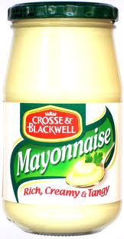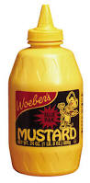
1._mayonnaise__ 2._________________ 3._________________
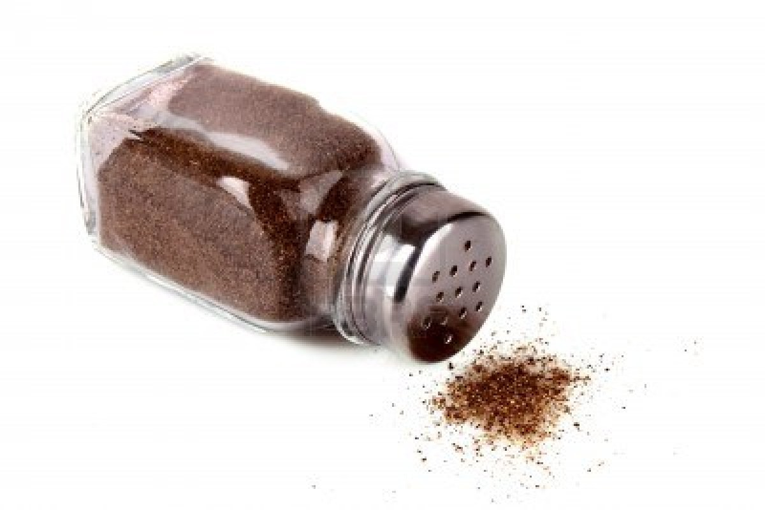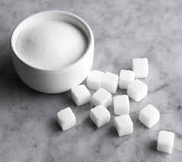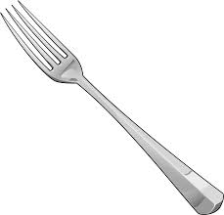

4._________________ 5.________________ 6.__________________

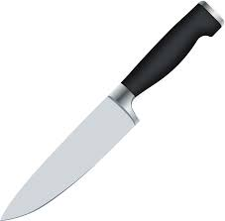

7.________________ 8._______________ 9.__________________

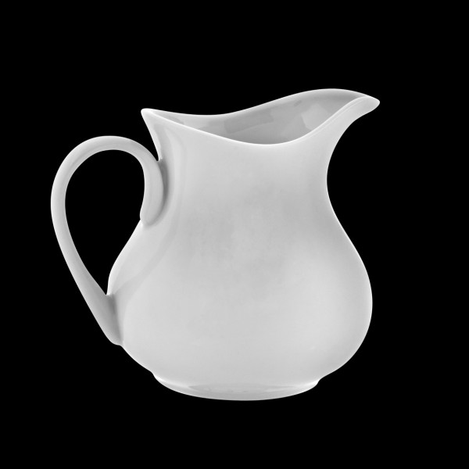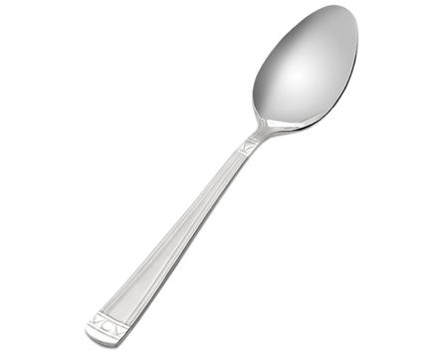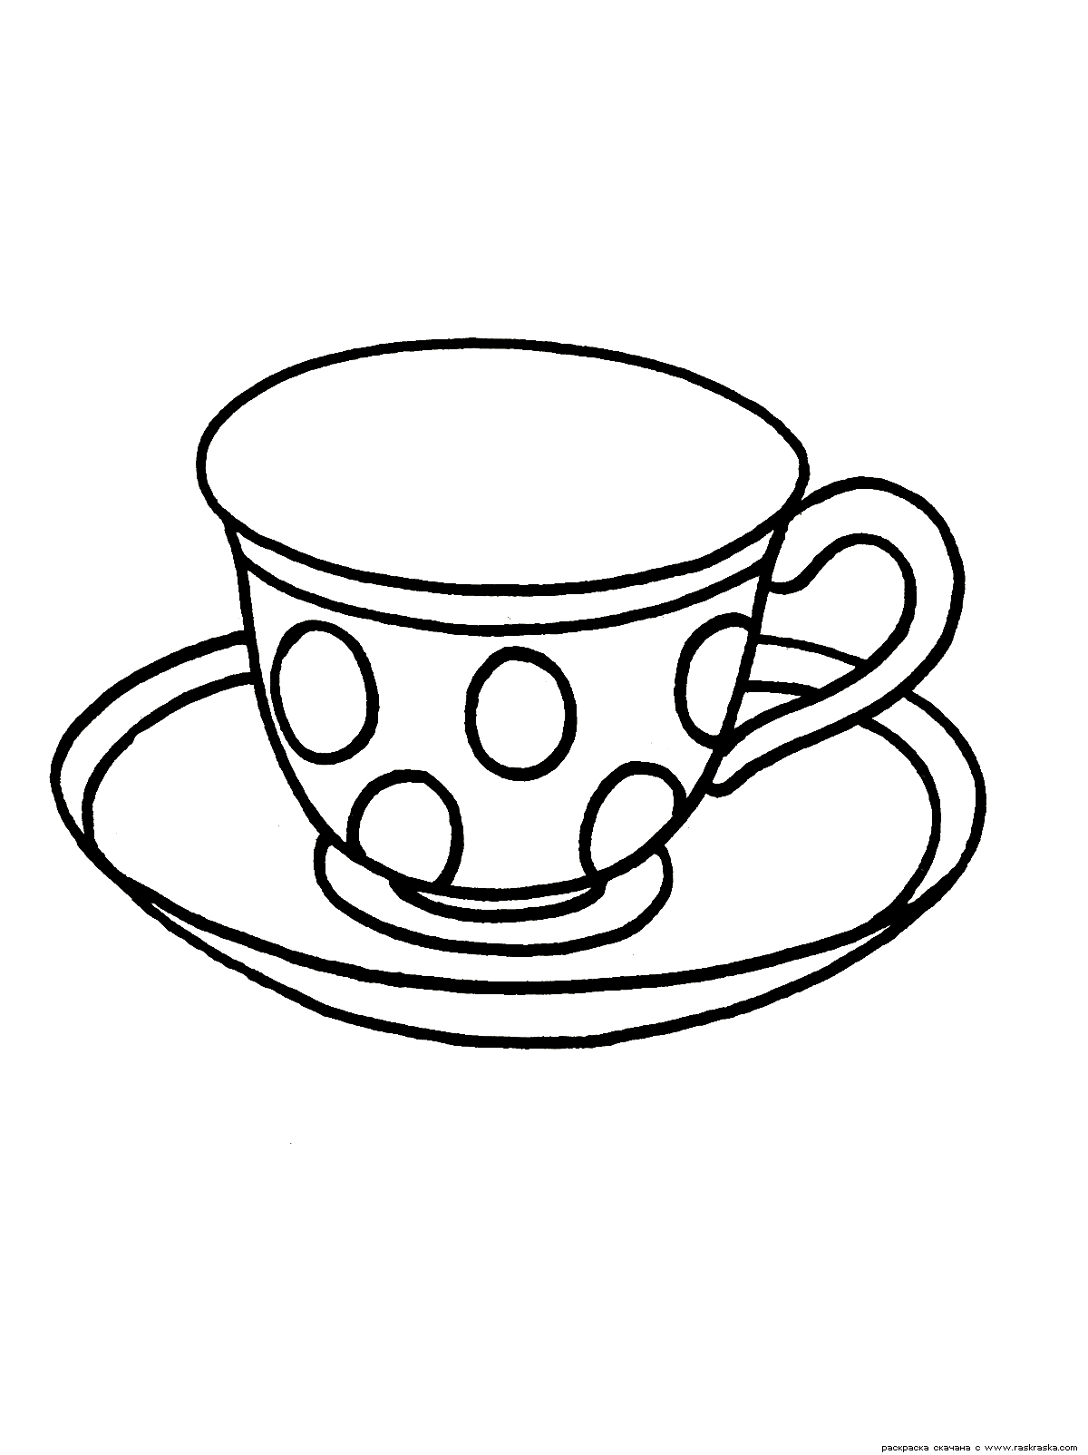

10._________________ 11.________________ 12.________________

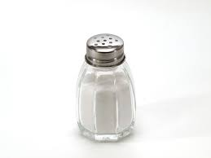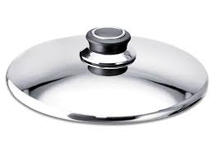

13.__________________ 14.________________ 15._________________

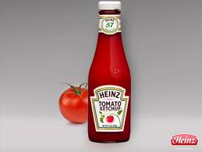

16.___________________
What does a good server say to customers? It depends on the situation. Read about the situation on this page. If the customers are happy and satisfied, the server can relax.
Customer: That meal was delicious.
Server: That glad you like it.

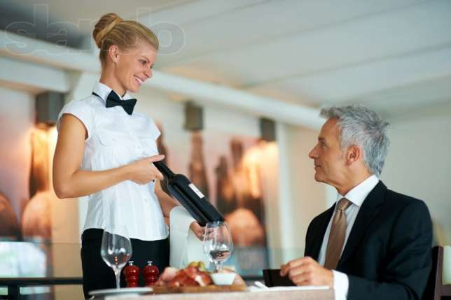

Sometimes customers aren’t satisfied with their order.
The server should apologize and solve the problem.

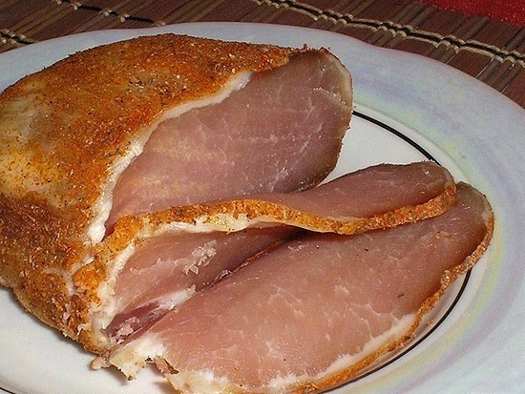 Customer 1: I asked for this steak well-done.
Server: I’m sorry. I’ll take it back and have I
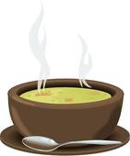 cooked some more.
Customer 2: My soup is too salty.
Server: I’m sorry. Can I get you something
else?
Customer 2: Excuse me. This is too much. I
only had a cup of coffee.
Server: You’re right. That’s our mistake.

Customer: We ordered twenty minutes ago. Server: I’m very sorry. I’ll check on your order.

Sometimes the customers are unhappy with the bill. The server should always be polite and check on the bill.
Customer 1: Waitress, this bill can’t be right. It’s much too high.
Server: I’ll check it for you.

Customer 2: Excuse me. This is too much. I only
had a cup of coffee.
Server: You’re right. That’s our mistake.
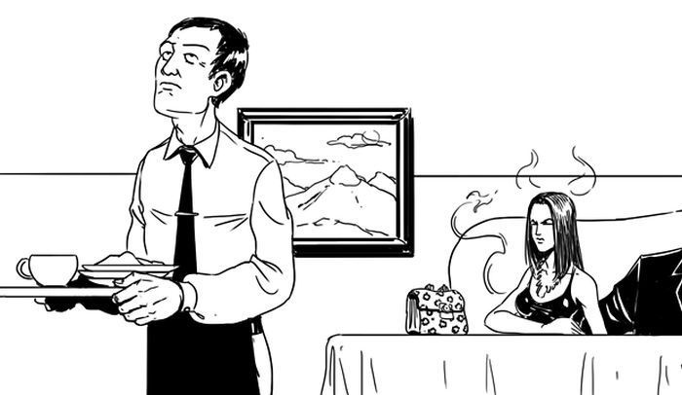

Step 1: Read the common things that customers say. Then read how a good server responds.
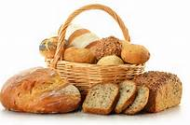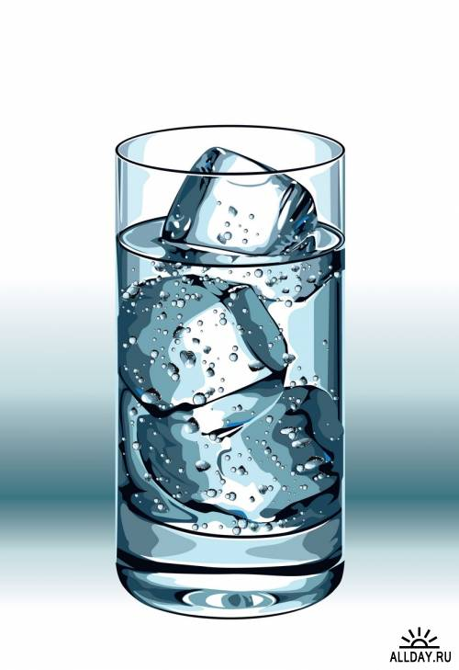
1. Customers say:
" I'd like water".
" Waiter, can we have some bread?"
" There are no rolls left. We need some more."
" We need some salt. There's none on the table."
Server says:
" I'll bring some right away"
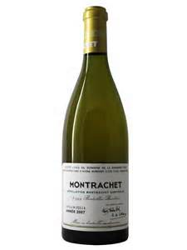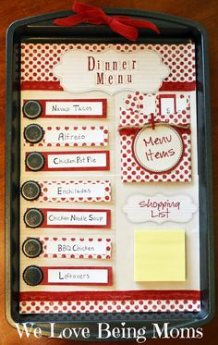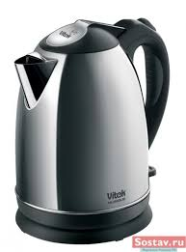

2. Customers say:
" We need one more menu".
" Another bottle of white wine, please."
" I'd like a refill on my coffee, please."
" May I have another soda?"
" I'd like another beer."
Server says:
“I’ll get one for you.”

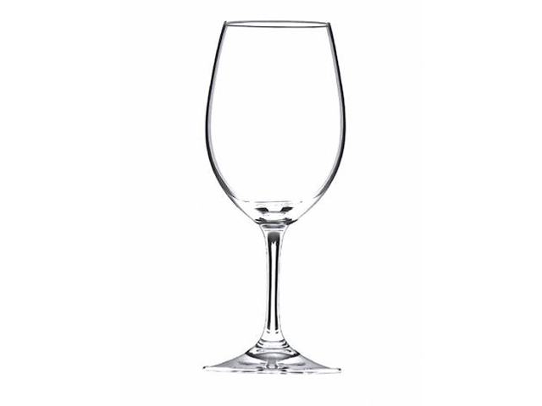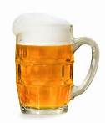

3. Customers say:
" Waitress, my glass has lipstick on it."
" I dropped my fork on the floor."
" My cup is dirty."
Server says:
" I'll get you a clean one."

Step 2: Match the customer's problem with the server's response. Draw a line from what the server says.
What the Customer says: What the Server Says:
1. "This bill is not correct" "I'm sorry about that. I'll check it
for you."
2. "We ordered fifteen minute ago" "I'll get you another one right now."
3. "The dinner is delicious. " I'm glad you're enjoying it."
4. "I need another napkin." "I'm sorry. I'll check on your
order."

Step 1: Circle the letter of the best answer.

- What kind of soup do you have?
- The halibut is very good.
- Strawberry shortcake.
- Clam chowder or bean soup.
- What does it come with?
- The shortcake is delicious.
- Ok. I'll have some.
- It comes with soup or salad.
- What kinds of salad dressing do you have?
- Ranch, blue cheese, or Italian.
- Ok. I'll get some for you.
- It comes with dessert.
- What's the special?
- Coffee, please
- The special is halibut.
- That's all.
- What do you recommend?
- Dessert, please
- What does it come with?
- The bean soup is delicious.
- May I have some hot coffee?
- The bread here is delicious.
- Certainly. I'll get some for you.
- Ok. I'll have some.

Step 2: Read the customer's questions and server's answers.
Then practice with a partner. Change the server's answer
each time.

Customer: What do you recommend?
Server: The vegetable soup is very good.
The strawberry shortcake is our most popular dessert.
Try our steak and salad.
Try the chicken wings. They are delicious.
The potato skin are great.
Customer: What are the special tonight?
Server: Roast chicken with white wine sauce is our special.
Our special dessert is lemon pie.

Words to Know:

above  below | between  in the center (of) | next to  on the left (of) | on the right (of)  on top (of)  under

Step 2: Circle the word in parentheses that best completes each sentence.

1. The salad fork goes on the left of, on top of the dinner fork.
2. The dinner plate goes (above, between) the forks and the knife.
3. The water glass goes (next to, above) the spoons.
4. The knife goes (on the right of in the center of) the dinner plate.
5. The dinner fork goes (next to, on the right of) the dinner plate.
6. The salad plate goes (under, on the left of) the dinner plate.
7. The soupspoon goes (below, in the center of) the water glass.
8. The cup goes (next to, on to top of under) the table.
9. The salt and pepper shakers go (in the center of under) the table.
10. The bread plate goes (below, above) the salad fork.
11. The sugar bowl goes (between, in the center of) the table.
12. The saucer goes (above, under) the cup.
salad fork | dinner fork | cup and saucer | water glass
wineglass | teaspoon | dinner plate | soupspoon
cream pitcher | sugar bowl | bread plate | napkin
steak knife | salad plate | knife | salt and pepper shakers

Write the correct word from the box under the picture.

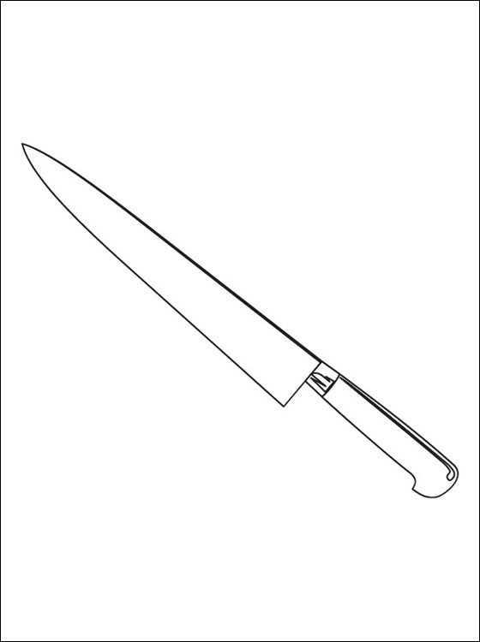
1.___________ 2.____________ 3.____________ 4.________

5.___________ 6.____________ 7.____________ 8.__________

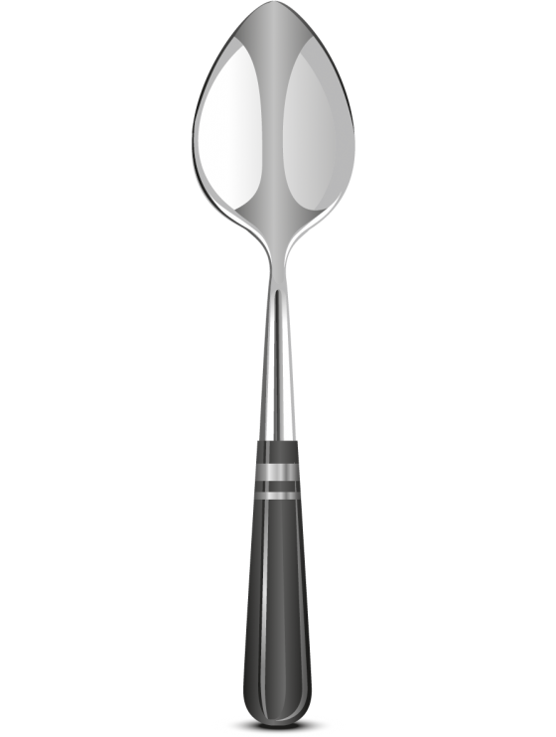
9.____________ 10.___________ 11.___________ 12.__________

13.___________ 14.___________ 15.___________ 16.__________

Use the words in the box to fill in the puzzle.

Attitude  Break  Customer  Job | Manager  Me  Order  Police | Ready  Team

1
 |  | 2
 |  |  |  |  |  |  | 3
 | 4
5 |  |  |  |  |  |  |  |  | 6
 |  |  |  |  |  |  | 7
8
 |  |  |  |  |  |  | 9
 |  |  |  |  |  |  |  | 10

Across. Down.
4. Bob has a good ______ 1. Always smile and be _________ .
about has job.
2. The _______comes first.
7. Are you ___________ to order 3. May I take your ________________?
8. Elena and Lee wait for the ___ 5. I want to keep my _____________.
____ to talk. 6. The_______________ is the boss.
9. I'll help you. We're a _
______ here.
10. Excuse ______ .
You are a server. Circle the letter of the correct answer.
1. The customer says, "I'm ready to order."
a. I bring the customer hot coffee.
b. I say: "I have to go on break."
c. I say, "May I take your order?"

2. The customer says, "I need a napkin."
a. I bring the customer hot coffee.
b. I say, "I'll get one right away."
c. I say, "I'm too busy."

3. The customer says, " I'm in a hurry. I want my dinner now."
a. I bring the customer hot coffee.
b. I set the table.
c. I say, "Ok, I'll check on your order right away."

4. The customer says, "May I have a little coffee, please?'
a. I bring the customer hot coffee.
b. I say, "I'm sorry. I'm no my bread."
c. I say, "Are you going to the movies tonight?"

5. The customer says, "I'm ready to order. I can't wait."
a. I say, "I'll be right with you."
b. I say, "I'll get you some."
c. I bring the customer hot coffee.
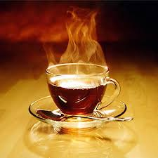
Choose the best answer for a host or hostess.
- A caller says, “I want to book a table.” What do you say?
- “I can show you to a table.”
- “How may I help you?”
- “When would you like the reservation for?”
- A caller wants to make a reservation for Friday night at 6:30 p.m., but you’re completely booked for that time. What do you say?
- “ I’m sorry, but we’re completely booked until 7:30 on Friday.”
- “When would you like the reservation for?”
- “May I have your name, please?”
- You want the girl to set up a table for a party of eight. What do you say?
- “How many are there in your party?”
- “Please set up table six for a party of eight right away.”
- “Is this eight people for a birthday party?”
- You don’t hear clearly what the phone caller is saying. What do you say?
- “Do you have a reservation?”
- “How may I help you?”
- “Could you please speak a little louder? I can’t hear you.”
Read each question. Circle the letter of the best answer.
- Do you take credit cards?
- I don’t know.
- I’m not sure. I’ll find out for it.
- What do you think?
- What kind of soup do you have?
- I’ll take a bowl, please.
- Would you like some crackers?
- Our soups today are cream of mushroom and navy bean.
- Would you carry my tray for me?
- Take your tray and come this way.
- Yes. I’d be happy to do it.
- No, thank you.
- Can I do anything to help?
- Wonderful. The condiment stand looks nice and neat.
- Yes. Please refill the salad bar.
- No!
- This is my first day. What do I do?
- Take your tray and come this way.
- We take all major credit cards.
- Just be friendly and patient.
- Do you have any specials?
- The customers need time to decide.
- Just be patient and friendly.
- We have a two-for-one special.
- Can we use this coupon?
- Yes, just show it to the cashier.
- I don’t know.
- You can buy items a la carte.
- Your special sounds good. What is it?
- Here you are.
- You can use the coupon.
- Soup or salad is free with your entrée.
- Are the steam tables hot?
- Yes. Be careful. You can burn yourself on them.
- No, they aren’t.
- Talk to the manager.
- Can you do it by yourself?
- Yes, thanks. I’m OK.
- I have to go home.

Read the clues for the crossword puzzle.
Then fill in the puzzle with words from the box.

aim  blade  board | cover  falling  fire | foil  handle  knives | mop  rules  slippery

 |  |  |  |  |  |  |  |  |  |  | 1
 |  |  |  |  |  |  |  |  |  |  |  |  |  |  |  | 2 |  | 3
 |  |  | 4 |  | 5
6
 |  |  |  |  |  |  | 7 |  |  |  |  |  | 8
9 | 10
 |  |  |  |  |  |  |  |  |  |  | 11

Across Down
5. Never try to catch a ______ 1. It's dangerous to walk on _____a floor.
____ knife.
2. Never play with _________
6. Never put __________in a 3. Always use a cutting__________
microwave oven. 4. The __________ of a knife is sharp.
5. Use an extinguisher to put out a
7. Use a ____________to clean _______

up spilled liquid on the floor. 10. _______ the fire extinguisher at the
base a fire.
8. You can put out a grease fire if
you __________the pan with a lid.
9. Squeeze the ____________of a
fire extinguisher to put out a fire.

11. It's important to follow safety
__________ .

Guide-interpreter service

Finishing school is the beginning of the independent life for millions of school leavers. Many roads are open to them: technical schools, institutes and universities. But it is not an easy thing to choose a profession out of more than 2000 existing professions in the world. Some pupils follow the advice of their parents, others can't decide even after leaving school.
Choosing the kind of career to follow is probably one of the most important decisions you will ever make. Before you make this decision you will have to do a lot of thinking about who you are, about the things you like to do and the things you do well. It is an advantage to choose a future career while at school. It gives a goal to work towards and enables to choose a right, suitable course of study. When deciding your future you must be realistic about your interests and abilities.
There are a lot of magazines for teenagers that often offer questionnaires, quizzes or surveys to help young people to see their interests and abilities more clearly and to make a decision concerning their future occupation.
Frankly speaking at present I have a very vogue idea about my future career and I am unable to give a detailed account of the activities it will involve.
But I am convinced that for every trade, profession or occupation you have to acquire necessary skills and practical experience. Not all professions require higher education and they are of great demand now and satisfy the needs of society. But I see things a little differently, because it is my firm belief that learning is the greatest of all adventures, and being a highly educated person gives you top priority and a position in society and what is most important - self-satisfaction. And now being not so far from leaving school the career sounds interesting to me if I have a higher education, good working conditions, if I can get steady salary, if it suits my interests, if it is not monotonous and gives me promotion in the future, if it helps me to establish myself in life and can give me independence and opportunities to develop special abilities and of course if I'm able to take it up and my interests can be channeled in to this work.
As for me in future I would like to become an interpreter. I know that interpreters have opportunities to visit different countries and continents. It attracts me, because I'll get acquainted with various peoples and I'll learn their customs, rituals and traditions. I'm sure that this creative profession enriches our mind and we become more educated. I think that an interpreter is a very useful profession, because it helps people to communicate. But of course if you want to be an interpreter, you will need definite qualification. At first you must know one foreign language at least. It's good, if you know English (the language of the planet) and any other language. Also you should know colloquial expressions and slang. You should know the history of the country the language of which you are studying, ways of life that are typical for this country, etc. And of course you must be a sociable, communicative and patient person. I think that this kind of career will suit me because I have almost all qualifications that are needed. But I must continue to work with English grammar and vocabulary as well and German pronunciation. I like this job and I hope that I'll become an interpreter. I hope that my dream will be realized. I try to read English books in the original, learn 10 words at a time and listen to English songs every day, because I want to fulfill my ambitions.

Excursion for sightseeing of Aktau

Monument of Taras Shevchenko

Monument Caravella
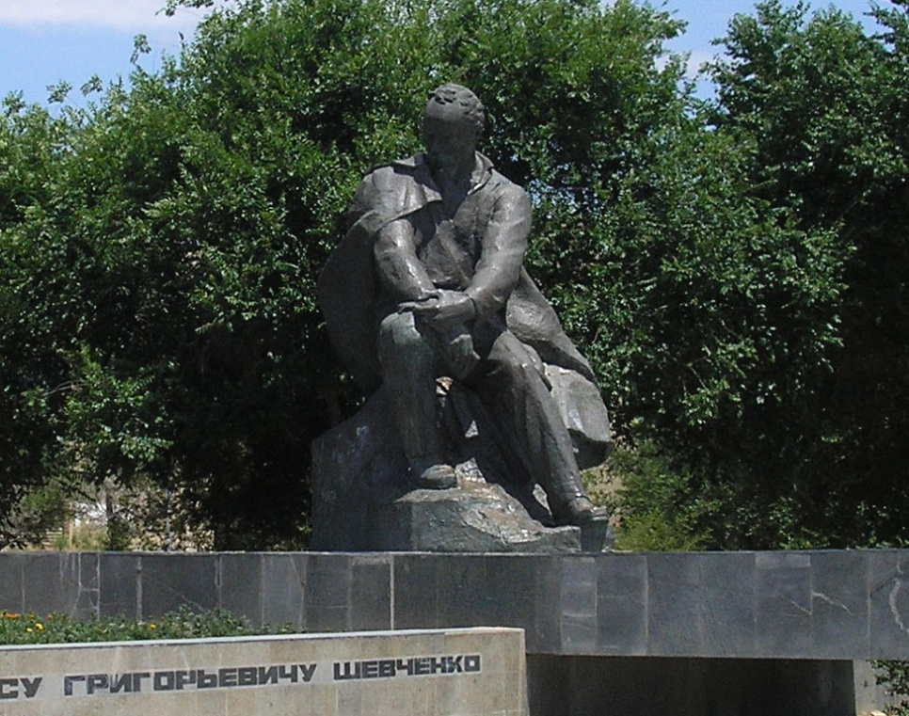Aktau ( Kazakh. Aқtau - «white mountain ") - a city in south- western Kazakhstan , the regional center of Mangistau region ( formerly called Mangyshlakskaya ) .
From 1964 to 1991 the city was called Shevchenko , after the Ukrainian poet Taras Shevchenko is at the beginning of the 19th century in exile in Kazakhstan.
In 1963, as a gift to the museum of Taras Shevchenko went bust artist and poet , made Ukrainian friends - sculptors Litvishinym and Kuznetsov. He replaced the lost and still do not know who sculpted from white marble original.
The history of its occurrence is . In 1881, the commandant of the Novo- Petrovsky strengthening Uskov , paying tribute to the talent of a former prisoner of the fortress, camouflage soldier Shevchenko ordered to fabricate and install a monument to him . Local master Carajas soon finished work on a pedestal . And in the house Uskova already stored referred to it by one of his contemporaries , apparently for fear of persecution and therefore wished not to be named, a bust of the Great Bard .
Monument in 1881 - the first in these parts after the disgraced poet - by order Uskova risk to himself was installed . On this there is documentary evidence of eyewitnesses. But in Soviet times the original bust was lost.
With special gratitude are in Ukraine to the sincerity with which the honor of Taras Shevchenko - akyn Tarazi - in Kazakhstan. Street named after him in many cities of the country. In Aktau, a monument to Taras

Shevchenko, created by the famous Ukrainian sculptor Vladimir Chepelykom and transmitted by the Government of Ukraine as a gift the people of Kazakhstan. In the town of Fort-Shevchenko is a museum of the great Kobzar .
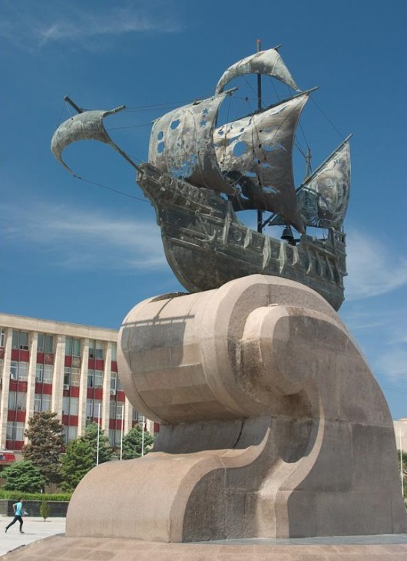 Three years the area near Aktau city administration forlornly empty. The local authority is probably the longest in Kazakhstan put up with the presence in the " Calvary " of the city idol era of socialism. It was only in 2000, Lenin decided to remove out of sight, in recreation park . Without the monument area unpleasant bare.
To fill the gap took Akim Mangistau region Bolat Palymbetov . Around January, he asked the sculptor and architect of the country: Aktau needs its own monument , something original ...
The idea is this , - explained the mayor - a young city , riding the wave of economic reforms , the city of the sea, the port ... It is necessary to emphasize its peculiarity , nautical theme ... Monument to become not only a symbol of the city and region , but also blend in with the landscape do not be too cumbersome, combined with the architecture does not take much space .
In response to akim brought a whole bunch of thumbnails. " They were mostly batyrs on horses - says Palymbetov . - For each Batyr had to ask walkers.
As a result, I have the choice was already an entire cavalry. Choose one, then the other will be offended, because every batyr are real people, descendants . As a result, a tender was announced, which took first place caravel Almaty sculptor and architect Edige Rakhmadiyeva Kazbek Zharylgapov .

Kashagan Kurzhimanula
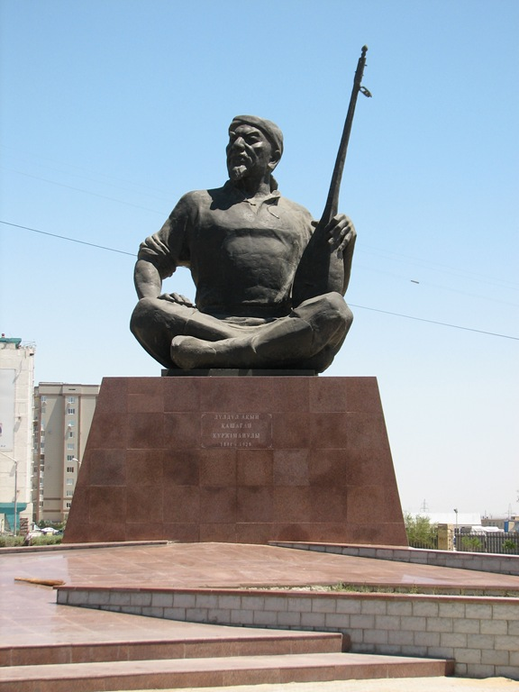 Kashagan of Kurzhimanula, Kashagan to a zhyra (years of life — 1841-1929) - the Kazakh akyn, to a zhyra, the prominent representative of the Kazakh oral and poetic creativity.
As the main basis for a reconstruction of shape of the legendary local akyn of Kashagan and its perpetuating the description of the well-known national singer and composer which reached our time on speech relay of ancestors served in bronze ….
The akyn Kashagan of Kurzhimanula - the famous mangystausky poet of the XIX century. From oral works of the great Kazakh akyn not a lot of things remained. Descendants were reached by legends and eposes. The best-known them them: "Origin of Adaya", "Earth of ancestors", "Surf".
Monument to Kashagan. Sculptor Kosher Baygaziev of Aktau, Kazakhstan.
In general the history of this monument isn't absolutely usual, and on its evolution it is possible to track a tendency of striking changes in a standard of living and cultures of inhabitants of these places that occurred in recent years. We will begin with that it already the third option of a monument of a kyuysha. However, the first of them could hardly apply for reckoning to works of monumental art, though was open to the 150 anniversary of this outstanding singer and composer in 1989.
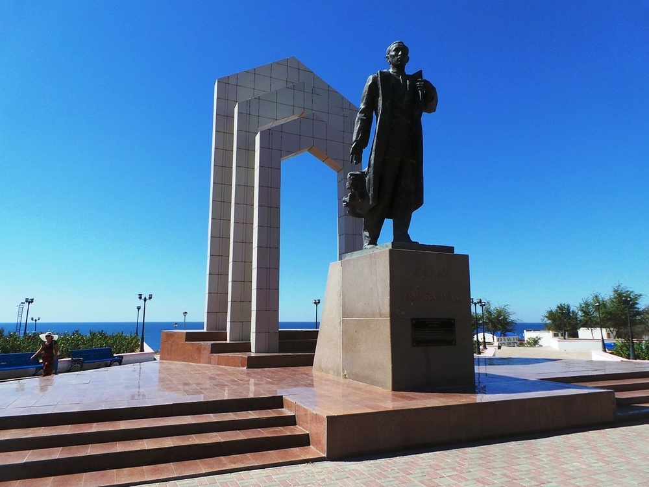Monument to Zhalau Mynbayev
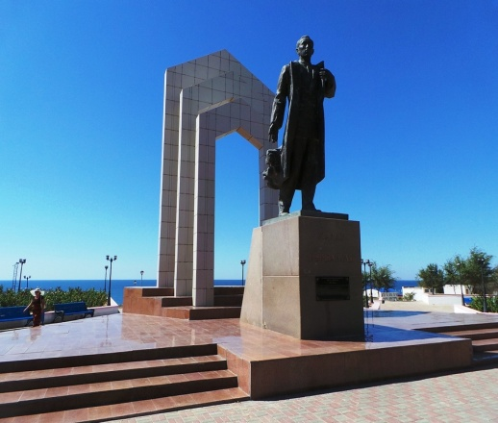 In Aktau opened a monument to the chairman of the Central executive committee Kazakh the Autonomous Soviet Socialist Republic for Zhalau Mynbayev. The name of the large politician who spoke out in defense of the simple people against Stalin repressions for many years was under a ban. But historical justice triumphed - at a monument to the hero of Mangistau grateful descendants gathered.
On an idea of authors of the project the distance between the sea and a monument is a course of life which there passed Zhalau Mynbayev. It began it the simple worker. I finished – the chairman of the Central executive committee. He in a fort was born Aleksandrovsk in 1892. In policy I came to youth. During civil war White Guards were going to shoot it. He remained to live and already in the twenties worked as the chairman of a revkom of the Adayevsky district, headed regional committee of the Ural province. On a post of the chairman of the CEC, Mynbayev was accused of communications with Trotskyists and sent to direct the Guryev party committee. It was not so much punishment, how many the prevention. But, nevertheless he refused to carry out a surplus-appropriation system and to raskulachivat the compatriots. Against Zhalau criminal case was brought, political prosecutions began. He died in 37 years. During Khruschev's thaw of Mynbayev rehabilitated. And only decades later in his honor weapon volleys thundered.
Kurmangazy Sagyrbayula.
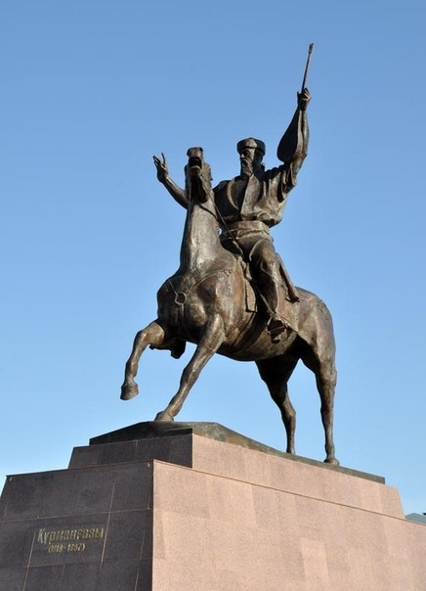 In Aktau will establish a monument to Kurmangaza Sagyrbayula's composer.
According to the Lada newspaper, this year Aktau will celebrate on September 30 the 48th birthday. The city authorities prepare a ceremonial opening of a monument of Kurmangazy Sagyrbayula for this day.
"The sculpture of the dombrist who became famous in the 18th century is mounted now on Yntymak Square in the territory of which large-scale reconstruction is also conducted. Opening of a monument and the updated central square is a gift for residents of Aktau from the city authorities", - reports the edition.
Kurmangazy Sagyrbayula (каз. Құрманғазы Сағырбайұлы ) — the Kazakh national musician, the composer, a dombrist. I had a great influence on development of the Kazakh musical culture.
In opening of a monument all management of the city of Aktau and Mangistausky area, and also veterans, school students and students participated.
We will note that over 146 million tenges were spent for production and installation of a monument together with full reconstruction of Yntymak Square.

Memorial "Eternal flame"
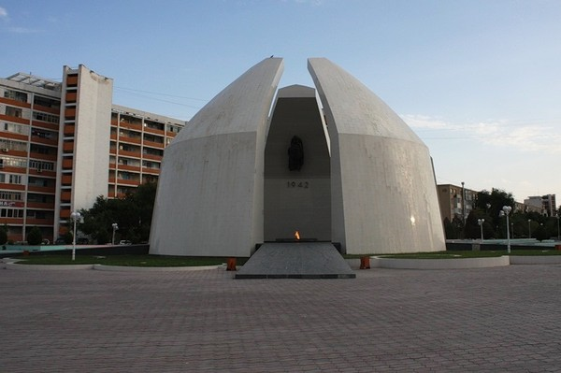 To the 40 anniversary of celebration of the Victory in the Great Patriotic War in Aktau the ceremonial opening of a memorial "Eternal flame" to soldiers – the mangyshlakets who fell in World War II battles took place …
The monument "Eternal flame" of Mr. Shevchenko (present Aktau) was opened in the Victory Day on May 9, 1985. The chief architect - E. B. Fedorov. The honourable right to light a flame was granted to the gentleman of an award Slava P. Malayevu.
From newspaper archive:
Snow-white stone petals are directed in the boundless sky. Outside the monument reminds the Kazakh yurta. Revetted with a light stone, "yurta" is below edged by gray marble. Inside – the floor paved by heavy plates from dark marble. On it – a five-pointed star from red granite in which the Eternal flame will be now lit. The star is surrounded with a wide bronze ring, on which inscription in the Kazakh and Russian languages: "Nobody is forgotten, nothing is forgotten".
The honourable right to light the Eternal flame is granted to the gentleman of an award of Glory of three degrees P. Ya. Malayev, the chairman of regional council of veterans I. D. Dzhambulatovy, the veteran of the war, the chairman of Shevchenkovsky city council of veterans G. N. Martynov, the serviceman P. I. Alimov studying high school No. 3 E. Sarbasova …
The exciting, touching moment. In a scarlet granite bowl blue fire flashes. There comes a moment of silence.
Содержание

- Пояснительная записка ……………………………………. 3
- Tourism industry……………………………………………... 5
- Hotel service………………………………………………….. 8
- Hotel staff. Hotel bedroom…………………………………... 19
- Reservation desk. How to deal with complaints……………...29
- Restaurant service………………………………………….…50
- Guide-interpreter service……………………………………..52
- Excursion for sightseeing of Aktau…………………………..57
- Monument of Taras Shevchenko. Monument Caravella………
- Kashagan Kurzhimanula. Monument to Zhalau Mynbayev…….
- Kurmangazy Sagyrbayula. Memorial "Eternal flame"………….
- Используемая литература……………………………………...

